**ASSIGNMENT 1**

|  |  |
| --- | --- |
| **Assignment Date** | **27th September 2022** |
| **Student name** | **Kavin malar G** |
| **Student Roll Number** | **211519106064** |
| **Maximum Marks** | **2 Marks** |

**Question-1:**

**Create form of type input text, email, password, radio button, text area, drop down andnavigate to successor page and display files of form in table (CSS, HTML)**

**Solution:**

**<html>**

**<head>**

**<title>Job Application Form</title>**

**<link rel="stylesheet" href="style.css">**

**<script type="text/javascript" lang="javascript" src="./responsiveRegistaration.js"></script>**

**</head>**

**<body>**

**<div class="col-md-6 offset-md-3 mt-5">**

**<h1>Job Application Form</h1>**

**<form accept-charset="UTF-8" action="https://getform.io/f/{your-form-endpoint-goes-here}" method="POST" enctype="multipart/form-data" target="_blank"><br>**

**<div class="form-group">**

**<label for="exampleInputName">Full Name</label>**

**<input type="text" name="fullname" class="form-control" id="exampleInputName" placeholder="Enter your name and surname" required="required">**

**</div></br><br>**

**<div class="form-group">**

**<label for="exampleInputEmail1" required="required">Email address</label>**

**<input type="email" name="email" class="form-control" id="exampleInputEmail1" aria-describedby="emailHelp" placeholder="Enter your email address">**

**</div></br><br>**

**<div class="form-group">**

**<label for="inputAddress">Address</label>**

**<input type="text" name="address" class="form-control" id="inputAddress" placeholder="1234 Main St">**

**</div></br><br>**

**<div class="form-row">**

**<div class="form-group col-md-6">**

**<label for="inputCity">City</label>**

**<input type="text" name="city" class="form-control" id="inputCity" placeholder="Istanbul">**

**</div></br><br>**

**<div class="form-group col-md-2">**

**<label for="inputZip">Zip</label>**

**<input type="text" name="zip" class="form-control" id="inputZip" placeholder="34000">**

**</div></br>**

**</div><br>**

**<div class="form-group">**

**<label for="example-tel-input" class="col-2 col-form-label">Telephone</label>**

**<div class="col-10">**

**<input class="form-control" name="tel" type="tel" value="1-(555)-555-5555" id="example-tel-input">**

**</div></br>**

**</div><br>**

**<div class="form-group">**

**<label for="example-date-input" class="col-3 col-form-label">Start Date</label>**

**<div class="col-10">**

**<input class="form-control" name="starting_date" type="date" value="2020-02-01" id="example-date-input">**

**</div></br>**

**</div><br>**

**<div class="form-group mt-3">**

**<label class="mr-4">Upload your CV:</label>**

**<input type="file" name="file">**

**</div></br>**

**<input type="submit"value="submit"onclick="SaveStudentDetails()">**

**</form>**

**</body>**

**</html>**

**OUTPUT:**

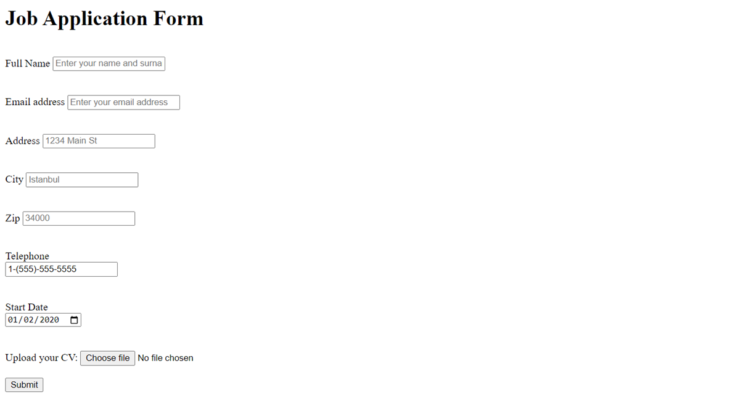

**Question-2:**

**For the CSS create external style sheet for above task (separate css file andlinkthat**

**in html)**

**Solution:**

**\*{box-sizing: border-box;**

**}**

**input[type=text], input[type=email], input[type=number], input[type=select], input[type=date],input[type=select],input[type=password], input[type=tel]**

**{**

**width: 45%;**

**padding: 12px;**

**border: 1px solid rgb(168, 166, 166);**

**border-radius: 4px;**

**resize: vertical;**

**}**

**textarea{**

**width:45%;**

**padding: 12px;**

**border: 1px solid rgb(168, 166, 166);**

**border-radius: 4px;**

**resize: vertical;**

**}**

**input[type=radio],input[type=checkbox]{**

**width: 1%;**

**padding-left: 0%;**

**border: 1px solid rgb(168, 166, 166);**

**border-radius: 4px;**

**resize: vertical;**

**}**

**h1{**

**font-family: Arial;**

**font-size: medium;**

**font-style: normal;**

**font-weight: bold;**

**color: brown;**

**text-align: center;**

**text-decoration: underline;**

**}**

**label{**

**padding: 12px 12px 12px 0;**

**display: inline-block;**

**}**

**input[type=submit] {**

**background-color: #4CAF50;**

**color: white;**

**padding: 12px 20px;**

**border: none;**

**border-radius: 4px;**

**cursor: pointer;**

**float:left;**

**}**

**input[type=submit]:hover {**

**background-color: #32a336;**

**}**

**.container{**

**border-radius: 5px;**

**background-color:#f2f2f2;**

**padding: 20px;**

**}**

**.col-10{**

**float: left;**

**width:10%;**

**margin-top: 6px;**

**}**

**.col-90{**

**float: left;**

**width: 90%;**

**margin-top: 6px;**

**}**

**.row:after{**

**content: "";**

**display: table;**

**clear: both;**

**}**

**@media screen and (max-width: 600px) {**

**.col-10,.col-90,input[type=submit]{**

**width: 100%;**

**margin-top: 0;**

**}**

**}**

**OUTPUT:**

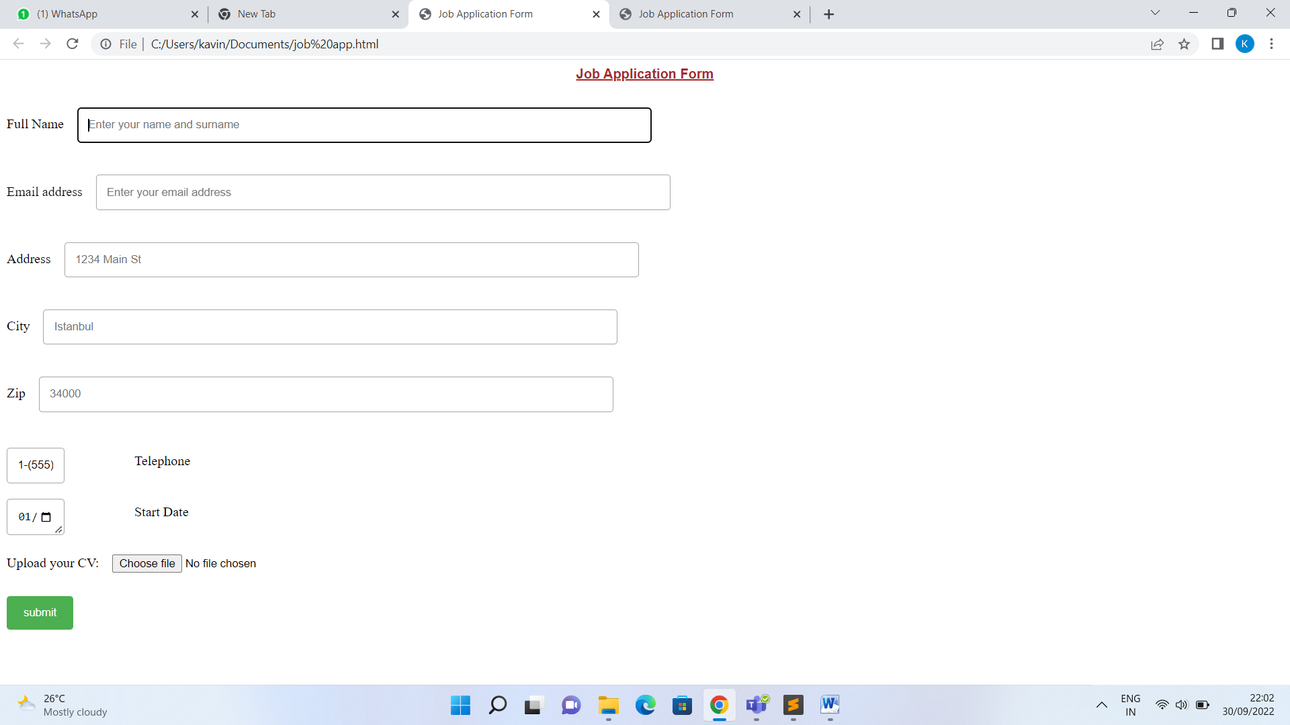

**Question-3:**

**Create sample program for Flask HTTP methods (list or map and performoperations of PUT, GET, DELETE and POST)**

**Solution:**

**F yrom flask import Flask,request,json**

**app=Flask(_name_)**

**cars={"1":"Lamborghini", "2":"Ferrari" , "3":"Porsche" , "4":"Landrover" , "5":"Bugatti", "6":"Mercedes" ,"7":"Rolls-Royce" , "8":"BMW"}**

**@app.route('/data' ,methods=['GET','POST'])**

**def api():**

**if request.method=='GET':**

**return cars**

**if request.method=='POST':**

**data=request.json**

**cars.update(data)**

**return 'data got inserted' @app.route("/data/<id>",methods=['PUT'])**

**def update(id):**

**data=request.form['items']**

**cars[str(id)]=data**

**return 'data updated' @app.route("/data/<id>",methods=["DELETE"])**

**def deleteoperation(id):**

**cars.pop(str(id))**

**return 'data deleted' if_name=='main_':**

**app.run(debug=True)**

**Output:**

